**OBJECT ORIENTED CONCEPT & PROGRAMMING**

**(SE-201) LAB-3**

**TAQI HAIDER_CSIT_SECTION:B_ROLL#CT-22092**

**Exercise:-**

**Q1:-**

#include<iostream>

using namespace std;

void factorial(int *x){

    int result=1;

    for(int i=1;i<=*x;i++){

        result *=i;

    }

    cout<<"The Factorial of "<<*x<<" is : "<<result<<endl;

}

int main(){

    int x;

    cout<<"Enter the value to find its factorial: ";

    cin>>x;

    factorial(&x);

    return 0;

}

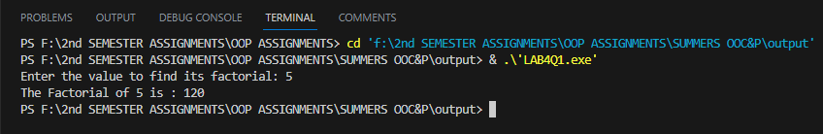

**Q2:-**

#include<iostream>

using namespace std;

void sum(int *arr1,int *arr2,int *sum,int size){

    for(int i=0;i<size;i++){

        sum[i]=arr1[i]+arr2[i];

    }

    cout<<"The sum of arr is:"<<endl;

    cout<<"{ ";

    for(int i=0;i<size;i++){

        cout<<sum[i]<<" ";

    }

    cout<<"}";

}

int main(){

    int size;

    cout<<"Enter the size of both the array at a time:"<<endl;

    cin>>size;

    int result[size];

    int arr1[size], arr2[size];

    cout<<"Enter "<<size<<" elements of arr1:"<<endl;

    for(int i=0;i<size;i++){

        cin>>arr1[i];

    }

    cout<<"Enter "<<size<<" elements of arr2:"<<endl;

    for(int i=0;i<size;i++){

        cin>>arr2[i];

    }

    sum(arr1,arr2,result,size);

}

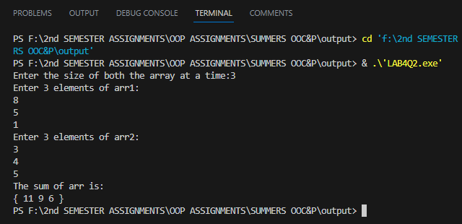

**Q3 :-**

#include<iostream>

using namespace std;

void circle_Area(double *r,double pi){

    double Area;

    Area=pi * *r * *r;

    cout<<"The Area of a circle is: "<<Area<<endl;

}

int main(){

    const double pi=3.142;

    double r;

    cout<<"Enter the radius of a circle: ";

    cin>>r;

    circle_Area(&r,pi);

}

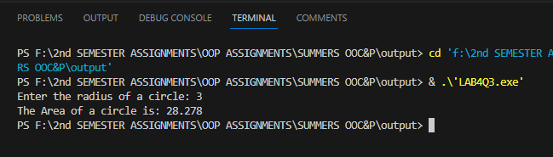

**Q4:-**

#include<iostream>

using namespace std;

void table(int *x){

    for(int i=1;i<=10;i++){

        cout<<*x<<" * "<<i<<" = "<<*x * i<<endl;

    }

}

int main(){

    int x;

    cout<<"Enter the no. to find its table:";

    cin>>x;

    table(&x);

}

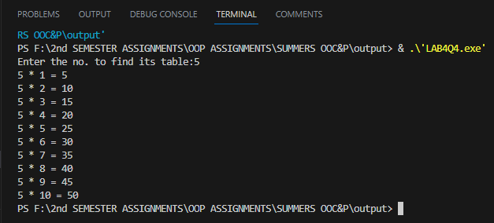

**Q5:-**

#include<iostream>

using namespace std;

class calculator{

    double x ,y;

    public:

    calculator():x(0.0),y(0.0){}

    void add(double *x,double *y){

        cout<<"The Addition of "<<*x<<" + "<<*y<<" is: "<<*x + *y<<endl;

    }

    void sub(double *x,double *y){

        cout<<"The Subtraction of "<<*x<<" - "<<*y<<" is: "<<*x - *y<<endl;

    }

    void mult(double *x,double *y){

        cout<<"The Multiplication of "<<*x<<" * "<<*y<<" is: "<<*x * *y<<endl;

    }

    void div(double *x,double *y){

        cout<<"The Divison of "<<*x<<" / "<<*y<<" is: "<<*x / *y<<endl;

    }

};

int main(){

    calculator c;

    double x,y;

    cout<<"Enter the First number:";

    cin>>x;

    cout<<"Enter the Second number:";

    cin>>y;

    c.add(&x,&y);

    c.sub(&x,&y);

    c.mult(&x,&y);

    c.div(&x,&y);

}

